National Water
Week

19-25 October, 2020
7 and over age category

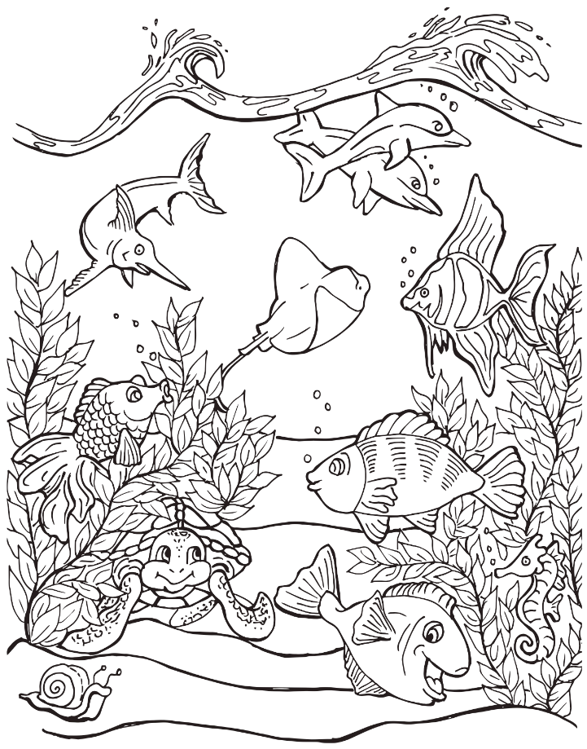

National Water
Week 2020

19 – 25 October 2020

Entrant Details

Name: ………………………………………………………………………………………………………………………………………………………………………………..

Address: ……………………………………………………………………………………………………………………………………………………………………………

……………………………………………………………………………………………………………………………………………………………………………………..……

Phone: ………………………………………………………………………………………………………………………………………………………………………….…..

Age: ……………………………………………………………………………………………………………………………………………………………………………………

Please ensure your entry is dropped at Thornton, East Maitland, Rutherford or Maitland Public Library by Saturday 17 October, 2020 to be in the running to win a water related prize.

Entries will be judged in two categories- Under 7, and 7 and Over with a prize per age group per library. Entries at each library will be displayed electronically during Water Week.

Should you wish to collect your entry following the Water Week display please ensure you return to the library where you dropped your entry on Saturday 24 October 2020. All entries after this date will be recycled.

Maitland City Council | National Water Week 2020

